

**BC2407: Analytics II – Group Project Report**

**AY21/22 Semester 2**



**Entity: DirectAsia Insurance**

**Instructor:** Assoc. Prof. Hyeokkoo Eric Kwon

|  |
| --- |
| **Seminar Group 3 Team 3** |
| Ananya Balehithlu |
| Charlynn Chia |
| Chua Jing Wen Rachel |
| Gao Yiping |
| Yeo Galvin |

Table of Contents

Executive Summary iv

1. The Business Problem and Our Approach 1

1.1 Situational Analysis/ Context 1

1.2 Business Problem and its Significance 1

1.3 Aims and Objectives 1

2. Data Preparation 3

2.1 Brief Description 3

2.2 Data Source 3

2.3 Data Cleaning 3

2.3.1 Missing & Duplicated values 3

2.3.2 Removing Irrelevant Variables 3

2.3.3 Conversion of Variables 3

3. Exploratory Data Analysis 4

4. Predictive Modelling Techniques 7

4.1 Train-Test Split of Data 7

4.2 Logistic Regression 8

4.2.1 Brief Introduction to Logistic Regression 8

4.2.2 Model Development 8

4.2.3 Model Evaluation 9

4.2.4 Model Interpretation 10

4.3 Neural Network 11

4.3.1 Brief Introduction to Neural Network 11

4.3.2 Model development 11

4.3.3 Modelling Process 12

4.3.4 Model interpretation 12

4.3.5 Model Prediction and Accuracy 13

4.3.6 Model limitation: 13

4.4 Random Forest Classifier 14

4.4.1 Brief Introduction to Random Forest Classifier 14

4.4.2 Model Development 14

4.4.3 Final Model 14

4.4.4 Model Prediction and Accuracy 15

5. Application of Findings 16

5.1 Final Model 16

5.2 Insights of Model 16

5.3 Business Recommendations 17

5.3.1 Web-Based Application With Underlying Random Forest 17

5.3.2 Fraud Deterrence and Mitigation using Real Time Insights 19

5.4 Limitations 20

5.5 Conclusion 20

6. References 21

7. Appendix 24

7.1 Data Dictionary 24

7.2 Logistic Regression Model Interpretation 26

7.3 Model Prediction and Accuracy of Neural Network 27

7.4 Dashboard 30

7.4.1 Logistic Regression Dashboard 30

7.4.2 Neural Network Dashboard 30

7.4.1 Random Forest Dashboard 31

7.5 R Shiny Web-Based Application Proof-Of-Concept 32

7.5.1 Actual Data 32

7.5.2 Application Demonstration 32

# 

# Executive Summary

Due to the Personal Data Protection Act, auto insurance companies are unable to share information with one another for fraud detection and rely on reporting to the General Insurance Association (GIA) to detect fraudulent claims. However, with the increasing rate of fraudulent activities, auto insurance companies are looking to implement machine learning techniques in their fraud detection aside from their reliance on the GIA. Hence, there is a need for DirectAsia Insurance (DAI) to implement machine learning in auto insurance fraud detection to reduce litigation costs and remain competitive in the industry.

This report aims to revolutionise DAI auto insurance fraud detection with machine learning by using predictive models to identify fraudulent claims before they have been processed as well as identify key variables to improve current processes by developing preventive measures.

Our team will be using the ‘Vehicle Insurance Claim Fraud Detection’ dataset from Kaggle. The dataset is ensured to be accurate, consistent, and complete through data cleaning, exploratory data analysis and visualisation. No intense data cleaning was required as the dataset was mostly complete. However, the dataset is unbalanced where approximately 95% of the outcome was no fraud. Hence, our team developed different methods of balancing the data to determine which set of balanced data would yield the most accurate predictions.

Through Proof of Concept (POC) the team applied various predictive models – Logistics Regression Model, Neural Network Model and Random Forest Model to determine which model is the best at helping DAI in minimising fraudulent case investigation costs while operating by the PDPA guidelines.

Our key findings are that our Random Forest model boasts the best performance with 63.08% accuracy, 92.42% sensitivity and 61.21% specificity in predicting fraudulent cases. This solution has significantly higher sensitivity than the existing detection rate in Singapore, and this would result in a 92.25% estimated decrease in cost. One notable point is to consistently apply all predictive models to any dataset as data may change overtime.

The team recommends DAI to adopt a web-based application with the Random Forest model underlying the application. This application will allow the claims processor to input the details of the claims and the application will prompt if it will be fraud or not. It will also collect data of the new claims to increase and improve the data used to develop the model in real time.

Another recommendation is to use the dashboard in real-time to monitor detection rates, use important variables used in the models to aid insurance investigators and to use commonly identified policy information in fraudulent cases as a focus of investigation to improve results.

In conclusion, DAI can now achieve higher detection rates, independence, lower costs, and increased time efficiency in their fraud detection process.

# The Business Problem and Our Approach

## 1.1 Situational Analysis/ Context

Motor insurance companies are facing a rising trend in motor claims where the number of claims increased by $42.1 million in a recent annual review conducted by GIA. This caused a significant decrease in profits by motor insurers as seen where ‘underwriting profit more than halved last year to $49.7 million’ (Tan, 2022).

Furthermore, there is also an increasing trend in insurance fraud committed. According to Straits Times, the Government received 3 times the number of reports of insurance fraud claims in 2022 as compared to 2018 (Ang, 2022). GIA also recently estimated that 20% of all motor insurance claims are fraudulent (McKinnon et al., 2020).

## 1.2 Business Problem and its Significance

Due to the Personal Data Protection Act (PDPA), it is difficult for motor insurance companies to share client information amongst themselves to do cross checking for detecting fraudulent insurance claims. This leads to many motor insurance companies, including DAI, to rely on GIA to detect fraudulent claims aside from their current manual detection process. However, this causes other challenges as the insurance companies would be unable to determine the accuracy of detecting insurance fraud, resulting in unnecessary costs and revenue loss for the insurance company.

It is significant for insurance companies to be able to detect fraudulent claims accurately and quickly as the cost for pursuing the fraudulent claims are high. Apart from facing high litigation costs, insurance companies face reputational damage due to their inability to prevent identify fraud in a timely manner and face uncertainty of winning litigation cases.

Therefore, there is an increasing number of insurance companies reducing their reliance on GIA by using machine learning and artificial intelligence to innovate ways in auto insurance fraud detection. Based on the research done for Accenture Technology Vision 2018, it was shown that more than 90 per cent of insurers are using, planning to use or considering using machine learning or AI in the claims or underwriting process.

To address the challenges due to overreliance on GIA and remain competitive in the industry, there is a need for DAI to incorporate machine learning techniques in their auto insurance fraud detection system. This will allow DIA to effectively identify fraud cases and prevent fraud claims, which will reduce the time needed to investigate each case and ultimately reduce their reliance on GIA. This is crucial for DAI in the long run as they aim to expand and grow as a company.

## 1.3 Aims and Objectives

The main objective of the report is to demonstrate how incorporating machine learning techniques in DirectAsia Insurance (DAI) will enable the company to make sense of historical fraud occurrences and to develop a system that allows them to identify fraud as an additional layer of authentication as well as identifying cases that are worth pursuing legal actions despite high litigation costs. This ultimately prevents unnecessary costs and revenue loss and allows DAI to remain competitive.

## 1.4 Our Approach

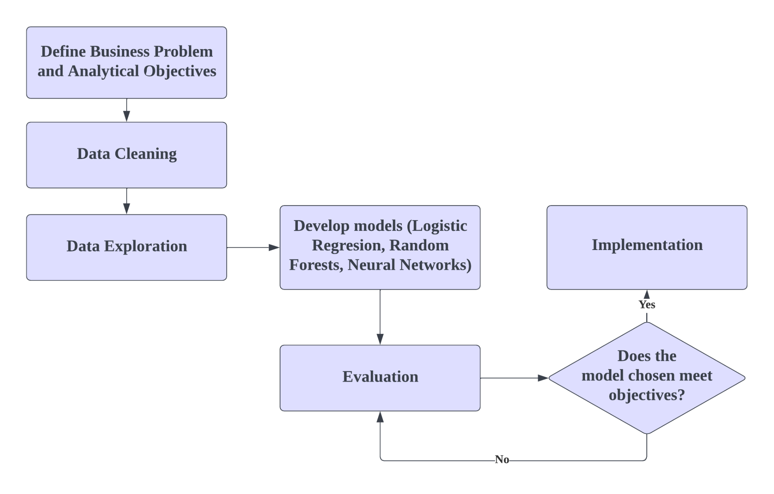

*Figure 1: Flowchart of DAI Analytics Team Approach*

Criteria for Evaluation

|  |  |
| --- | --- |
| Sensitivity | the ability to correctly predict a fraudulent claim which means fewer false negative results (predicted as non-fraud when it is a fraud). |
| Accuracy | the proportion of correct predictions over all predictions |
| Specificity | the ability to predict a non-fraudulent claim which means fewer false positives (predicted as fraud when it is not a fraud) |

For DAI, sensitivity would be a significant metric while considering the suitable accuracy and specificity level. Due to the low current detection rate for actual fraud occurrences, low sensitivity would be more costly as compared to false positives for DAI to reduce overall costs in fraud investigation. However, specificity and accuracy will still be considered as the machine learning model should not produce too many false positives resulting in unnecessary and fruitless fraud investigations.

Benchmark

As there is a lack of the specific detection rate in Singapore or the US, the British detection rate in auto fraud of 2.05% (Tarling et al, 2021) will be used as a benchmark throughout this report. To compare the implication of false-negatives to DAI, cost per undetected fraud in the UK of GBP 2,559 (McKinnon et al., 2020) has been used and while there is a lack of information on the cost of false-positives, it remains a consideration.

# Data Preparation

## 2.1 Brief Description

The dataset ‘Vehicle Insurance Claim Fraud Detection’ was selected to predict fraudulent auto insurance claims for DAI. The entire dataset contains 15,420 rows of data with 33 variables. The data was collected over 3 years from 1994 to 1996. It includes several demographic variables such as age, gender, marital status, etc, as well as the details of the automobile involved such as type, make, price, age of vehicle, etc. Other variables included describe the claim and the type of insurance policy.

The target variable “FraudFound_P” is a binary variable which reflects whether a claim application is fraudulent (FraudFound_P = 1) or not (FraudFound_P = 0).

With this dataset, we aim to develop a predictive model that could accurately predict whether a vehicle insurance claim is fraudulent with precise accuracy.

## 2.2 Data Source

This dataset was retrieved from Kaggle, a credible and trusted platform, where datasets are reliable and mostly complete. In our case, the data uploaded by the Kaggle user was extracted from Oracle’s database. However, data cleaning is needed as an additional precaution, as well as pre-processing before performing any further analysis.

## 2.3 Data Cleaning

Data cleaning helps to ensure that the data inputs are consistent and processes the data for use by predictive models.

### 2.3.1 Missing & Duplicated values

This dataset has no missing and duplicated rows of data.

### 2.3.2 Removing Irrelevant Variables

“PolicyNumber” is an identification variable and is independent of each claim application. “PolicyType” is a variable that is based on the categories within the “Base Policy” and “Vehicle Category” variables. Since these two variables provide no meaningful contribution to our analysis of the dataset, we decided to remove them from the dataset.

### 2.3.3 Conversion of Variables

After analysing the dataset, we found that there are 27 categorical variables and 4 continuous variables. There are few dichotomous variables, which is a type of variable that only takes on 2 possible values. “FraudFound_P” is a binary variable that can only take on 2 values, 0 or 1. Hence, these variables are converted into categorical variables. The rest of the categorical variables have multiple levels, where some represent numerical ranges. As these ranges do not provide much information that is useful to the model and would make the model development more complex, we generated random numbers within the ranges specified in the level so that more data values can be used in training the model. These variables are then identified as continuous variables. The rest of the categorical variables are converted to categorical variables as well.

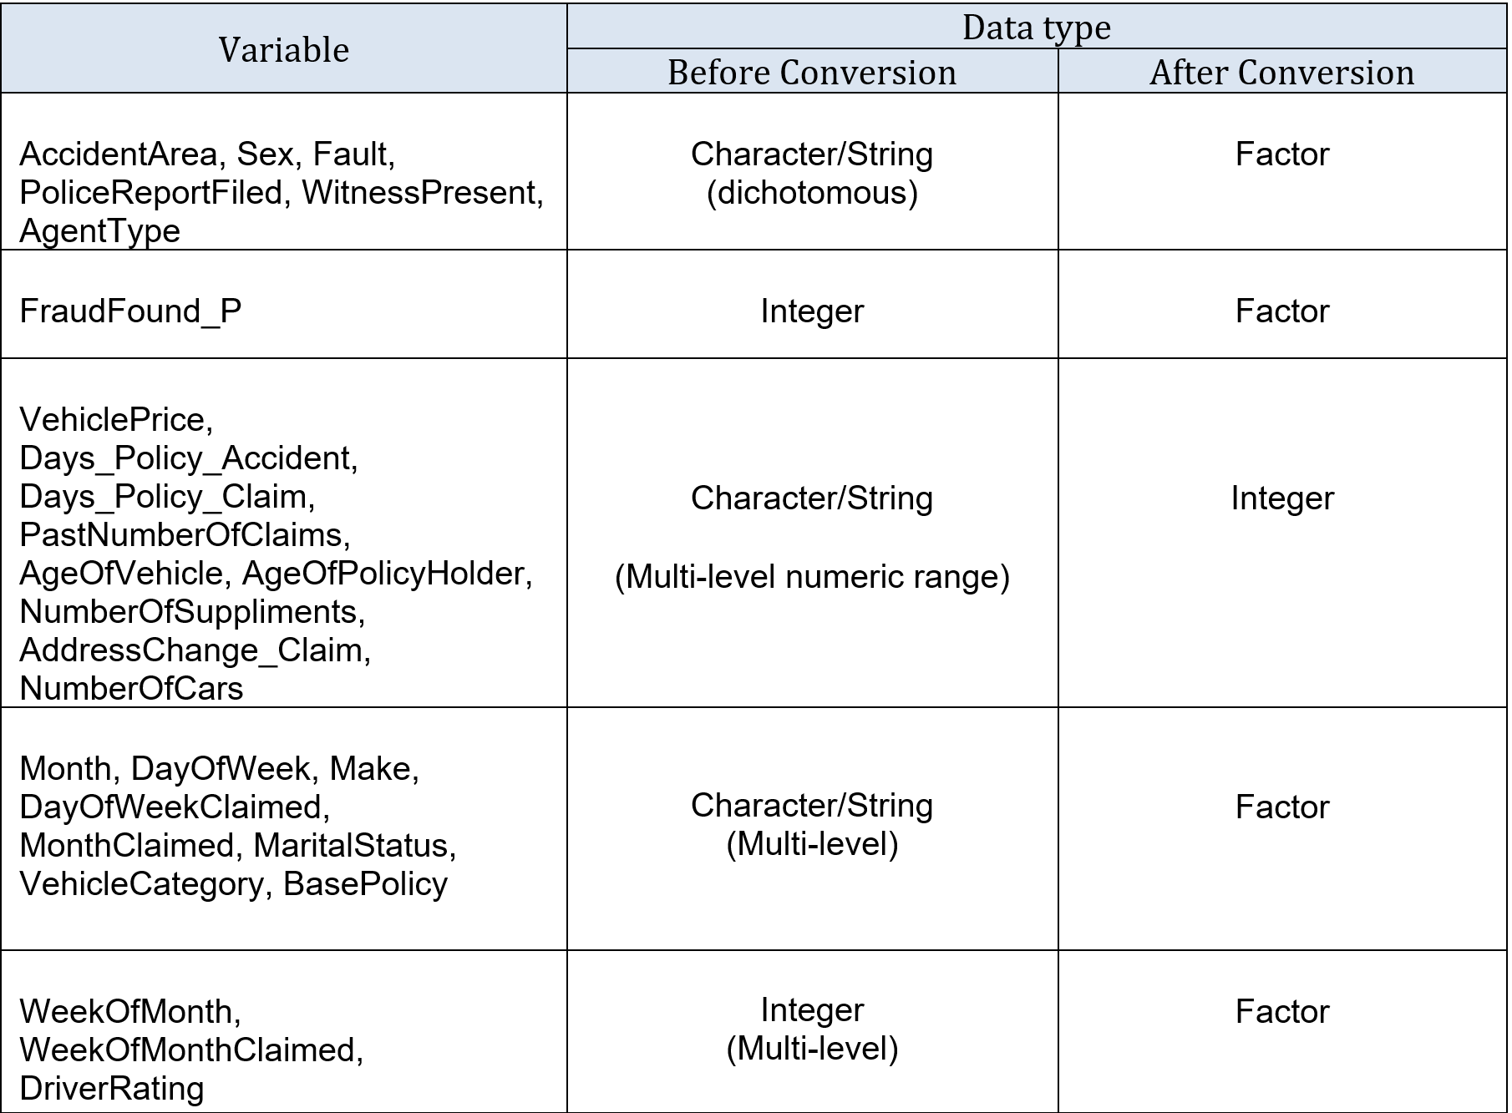

*Figure 2: Changes to Data Types after Variable Conversion*

After the conversion, the final dataset “fraud_clean” is left with 18 categorical variables and 13 continuous variables. The variable ‘FraudFound_P” is the dependable variable to be determined while all other variables are independent predictor variables.

# Exploratory Data Analysis

To gain better understanding of the dataset, the distribution of key variables and their relationships were plotted.

Demographics Distribution

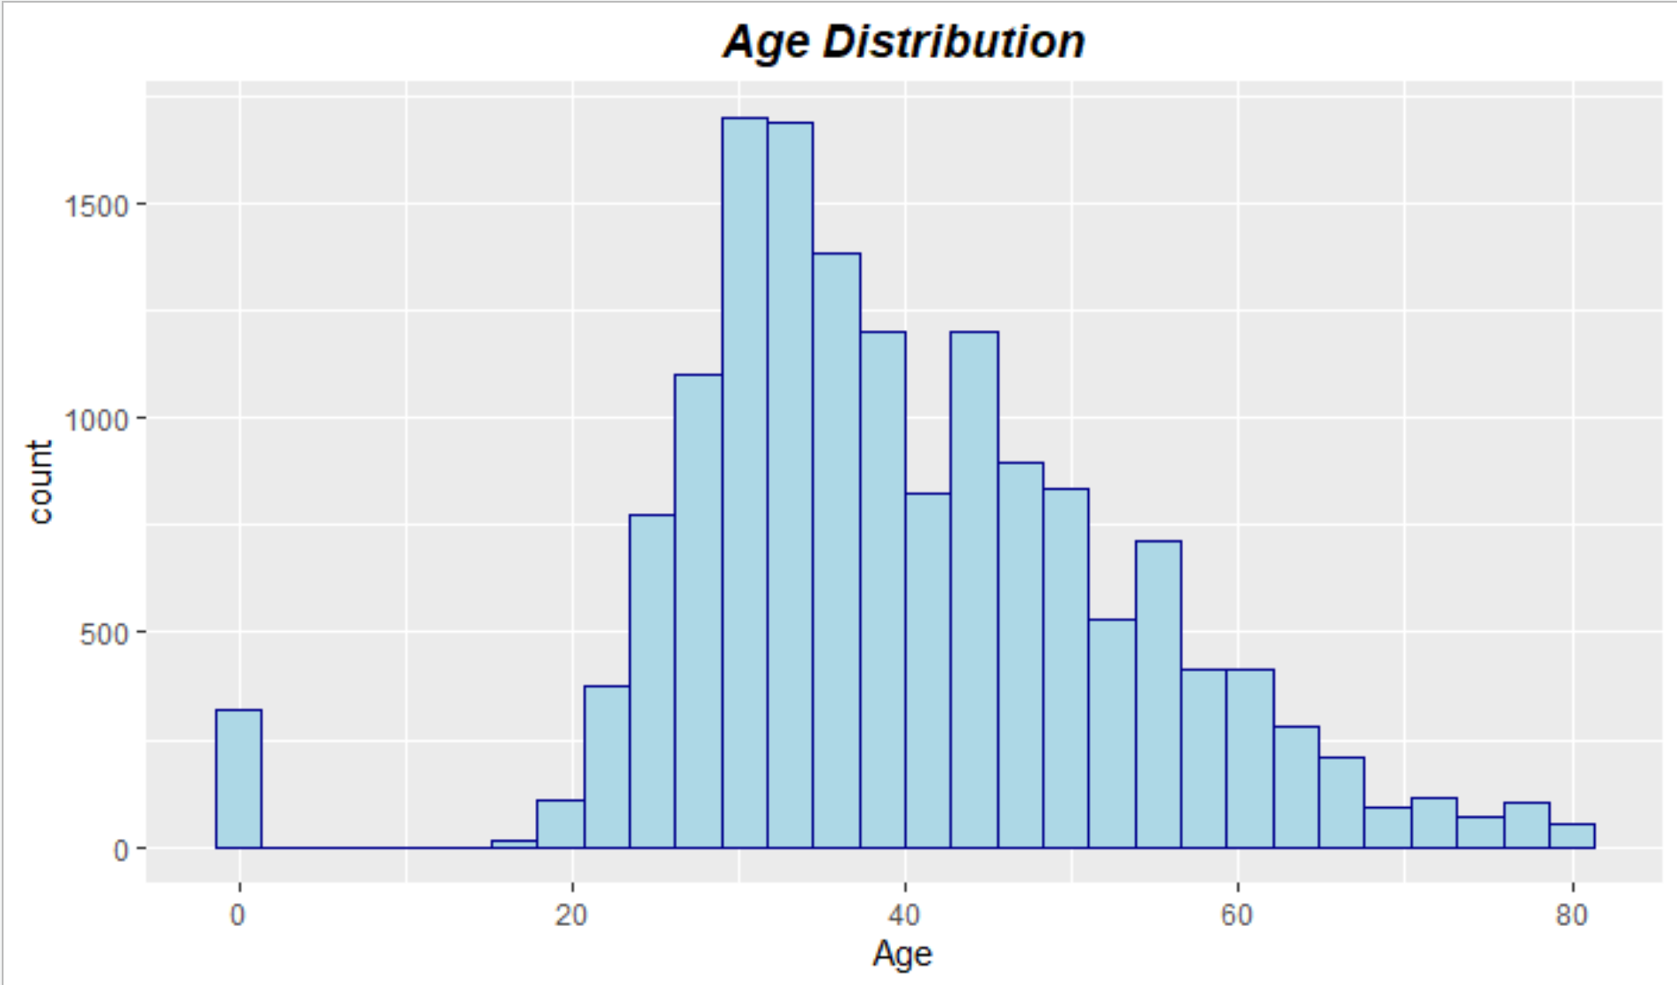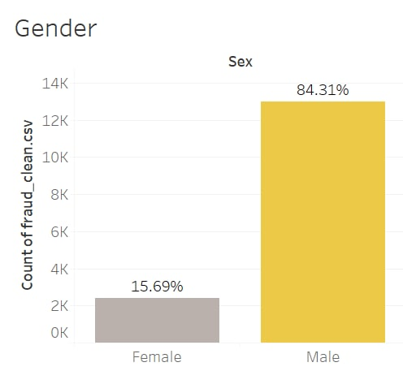

*Figure 3: Age Distribution Figure 4: Gender Distribution*

The histogram in Figure 3 shows that the ages of individuals who made a claim are between 16 and 80 years old, with more individuals between 26 and 35 years old. However, we can see that there are a few numbers (320) of individuals whose age is recorded as 0. As this is not possible, we will assume that the true age for these individuals were not recorded, and this absence may be a factor in deciding whether the claim is fraudulent or not. As such, we kept the 0 value as it is in the dataset for our analysis.

The bar graph in Figure 4 shows that there is a much higher proportion of males who made a claim as compared to females. As such, the data for “Gender” is heavily skewed towards the male population. However, this is an accurate representation of the proportion of males and females who make vehicle insurance claims. According to an article by DirectAsia, one of the reasons for charging males with higher insurance prices is that males are more likely to be involved in road traffic crashes than females, and so females generally make fewer claims than male drivers.

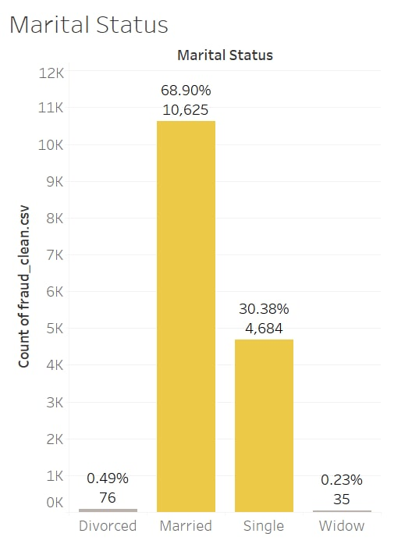 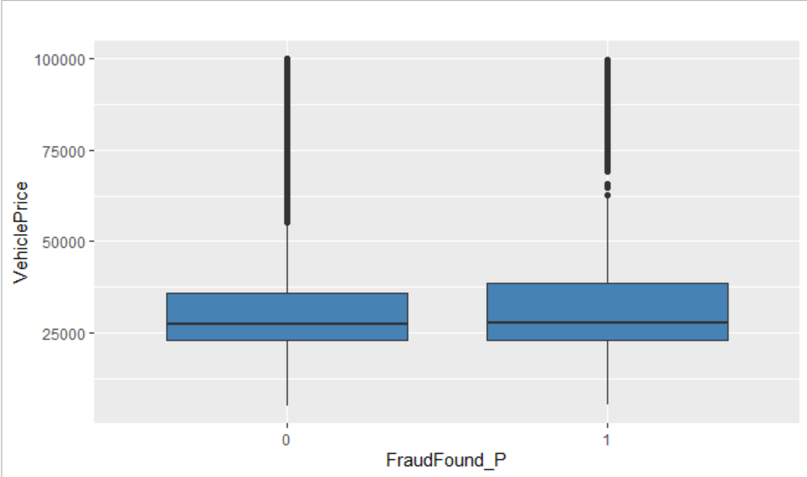

*Figure 5: MaritalStatus distribution Figure 6: VehiclePrice distribution*

Figure 5 shows that the majority of the individuals who made a claim are those who are married (around 69%), followed by Single (30%) and very few who are divorced or widowed. However, in general, insurance companies found that married drivers are less likely to file claims than drivers who are single, divorced, or widowed. Another finding is that from the boxplot shown in Figure 6, there are many outliers present in the VehiclePrice Variable. This is because most of the vehicles owned by the owners are in the lower price range. It is sensible that the data is skewed towards those who own cheaper cars since not many people will own vehicles with high prices.

Unbalanced Dataset

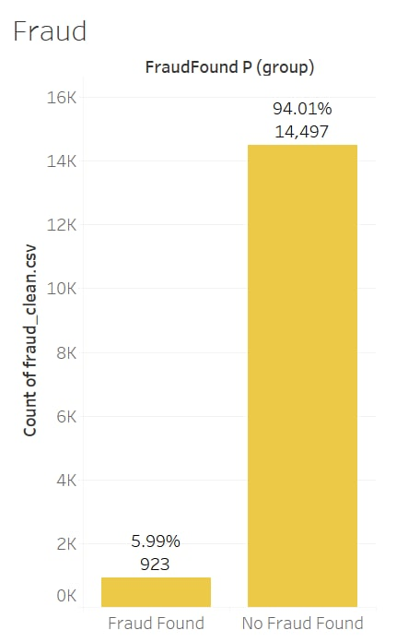 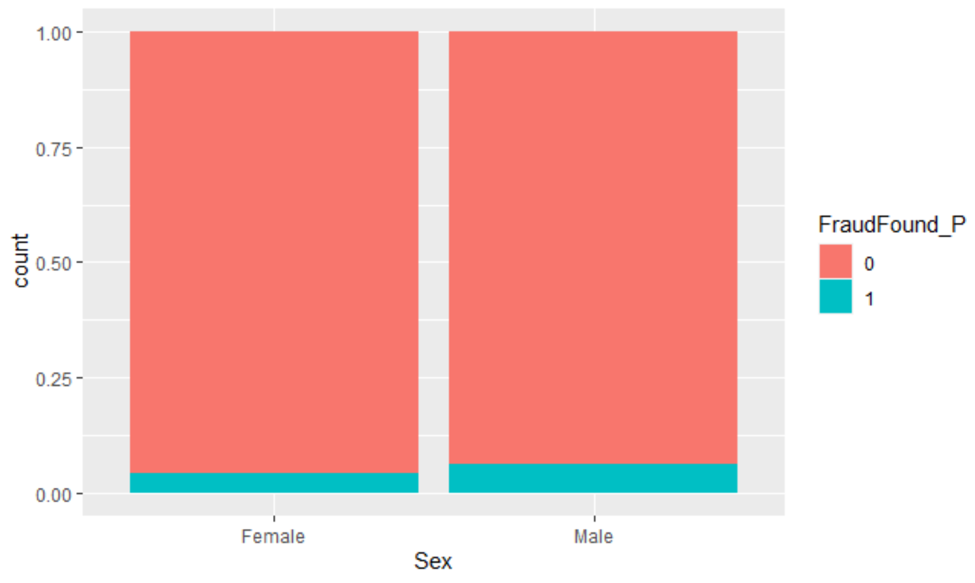

*Figure 7: FraudFound_P distribution Figure 8: FraudFound_P distribution of each gender*

From Figure 7, we can see that our dataset is highly imbalanced and is heavily skewed towards No fraud found (around 95% of claims are not fraudulent claims). As such, there is a need to balance the data before using it to train the model and the methods we have adopted will be described under Predictive Modelling Techniques. From the stacked proportion bar chart in Figure 8, we can see that there is little difference in the proportion of fraudulent claims found or not for both Male and Female. However, we can see that there is a slightly higher proportion that a claim is fraudulent for Males.

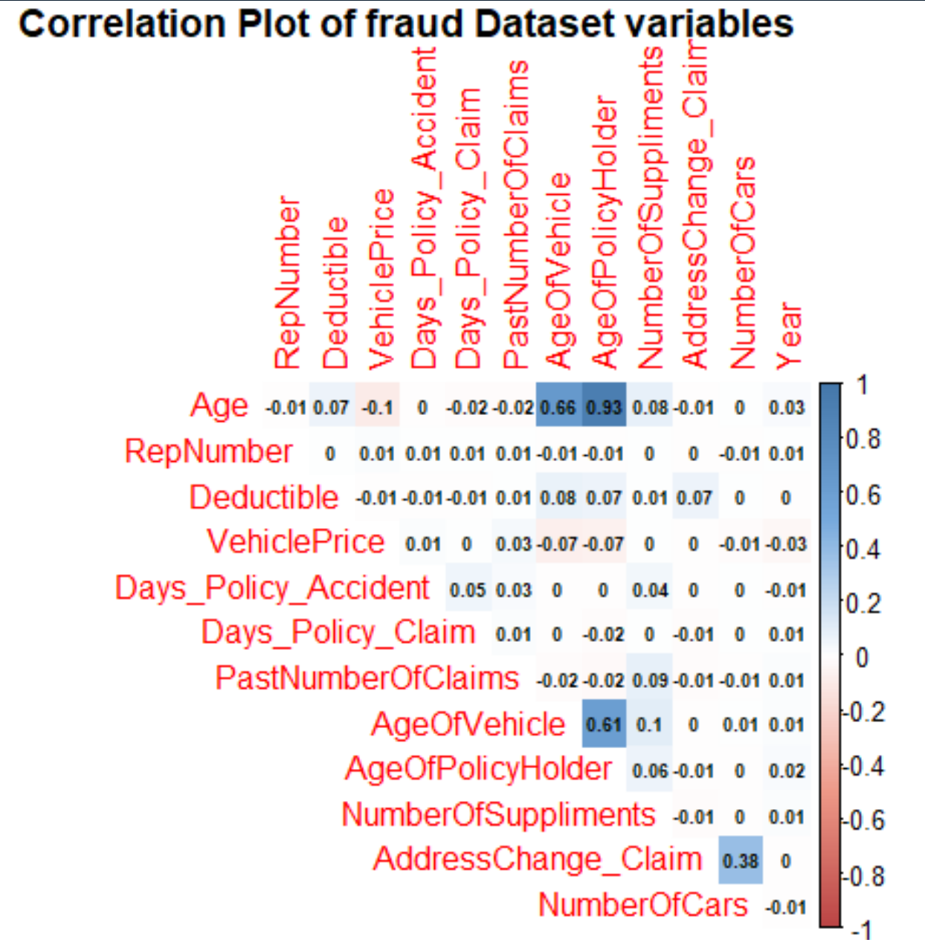

*Figure 9: Correlation Matrix of Continuous Variables*

From the correlation plot above, the only variables that have high correlation are *Age and AgeOfVehicle, Age and AgeOfPolicyHolder, AgeOfVehicle and AgeOfPolicyHolder*. Other than that, no pair of variables exhibit a strong correlation.

# Predictive Modelling Techniques

## 4.1 Train-Test Split of Data

To test the accuracy of the prediction, there is a need to split the data into a train-set and a test-set. The train dataset is used to fit the predictive model and the test dataset is used to get a good estimate of model performance. However, as seen in the data exploration process, the dataset is unbalanced where approximately 95% of “FraudFound_P” has the value of no fraud.

To solve this issue, 3 techniques will be explored to achieve a balanced data and the models will be built on all the different trainsets to determine its efficacy. However, it is important to note that the testing dataset used for all balancing types and models will be the same and unbalanced to ensure consistency for comparison. Sensitivity will be the priority of our analysis.

1. **Undersampling**

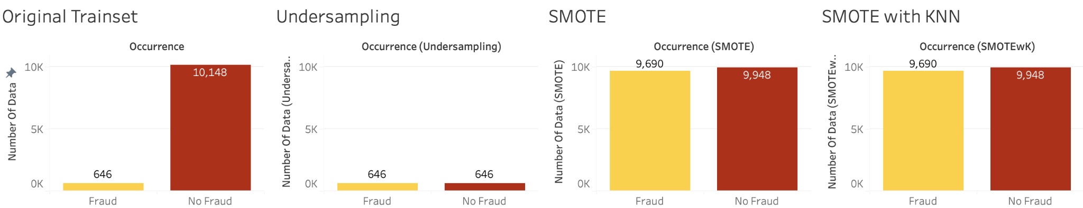

Undersampling is done by removing the additional rows of majority data to match the minority. The issue with this technique is that the removal of data results in a lack of data, as such the model may miss out on important information when it is being built.

1. **Hybrid Undersampling and Oversampling**



Oversampling can be done to increase the minority of the data synthetically. The issue with this is that the synthetic data may not be true to the case and may train the model based on poorly made synthetic data. Therefore, a mix of undersampling and oversampling using an R package, Synthetic Minority Oversampling Technique (SMOTE), was done to under sample the majority slightly and oversample the minority.

1. **Hybrid Undersampling and Oversampling with K-Nearest Neighbour algorithm.**

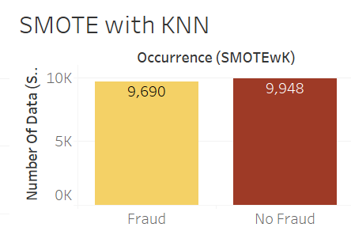

The K-nearest neighbour (KNN) algorithm is a method relying on the assumption of “birds of a feather flock together” (Harrison, 2018). This means that data points close to each other are assumed to be similar and thus the synthetic data can be derived from it. While there is no recommended number, 103 was set as the number of data used in the KNN algorithm based on standard practice where K should be an odd number and should be the square root of the number of data in the original training dataset.

## 4.2 Logistic Regression

### 4.2.1 Brief Introduction to Logistic Regression

The logistic regression model predicts the categorical variable Y based on the logistic formula:

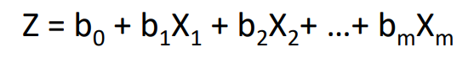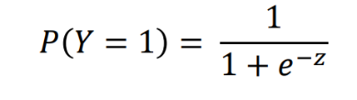

Where b0 is the intercept and bn is the coefficient for variable xn.

Logistic regression uses the historical pattern of other variables from the training data set to attempt to predict the probability of an occurrence being a fraud (*FraudFound_P* = 1). The threshold of 50% is used to predict whether it is a fraud.

For example, if the regression model calculates the probability of it being 40% fraud, it will be deemed as no fraud. On the other hand, if it is 60% fraud, it will be considered as fraud.

### 4.2.2 Model Development

The technique to build logistic regression starts with building a full model where the model is based on all variables in the training data set as the first model. (Model 0)

Next, a logistic regression model with backwards elimination will be built as the second model. This method removes all insignificant variables while ensuring that there will be no information loss after removing each variable. (Model 1)

The third model will be built by removing additional insignificant variables from the second model which the function did not remove to attempt to compare the accuracy. (Model 2)

Finally, variables that are correlated with each other (or multicollinear) will be removed as their inclusion may affect the accuracy of the model or it could affect the purpose of understanding the model. (Model 3)

While different models are built based on the steps, there are several considerations before determining the models. The full model may be an overfitted or complex model which may be difficult for users to collect the data required or it may be too precise and as a result, not transferable/flexible for other datasets. The following models are then decided based on the trade-off between their sensitivity, accuracy, and specificity before concluding the final logistic regression model.

### 4.2.3 Model Evaluation

The first metric used to evaluate the logistic regression technique is the trade-off between explainability and accuracy. As compared to the following analytic models, logistic regression has high explainability as one can understand the relationship of the variables with the prediction from looking at the model. For example, if the model formula is Fraud = 0.2YearsOfDriving, it would mean that for each year of driving, the odds of predicting fraud will be increased by e^0.2 which is 1.22 times more likely to be fraud. Therefore, selecting logistic regression would mean giving up some accuracy for understanding what determines a fraud occurrence or what does not.

The logistic regression was performed on the 3 different methods and at each method, all steps were tested for their accuracy on the train-set and test-set.

Referring to the table below, the selected model for logistic regression is model 2 of the undersampling technique. This model was selected as it has the highest sensitivity (87.73%) while foregoing only 4.26% accuracy and 4.99% specificity from its closest competitor, SMOTE with KNN model 1.

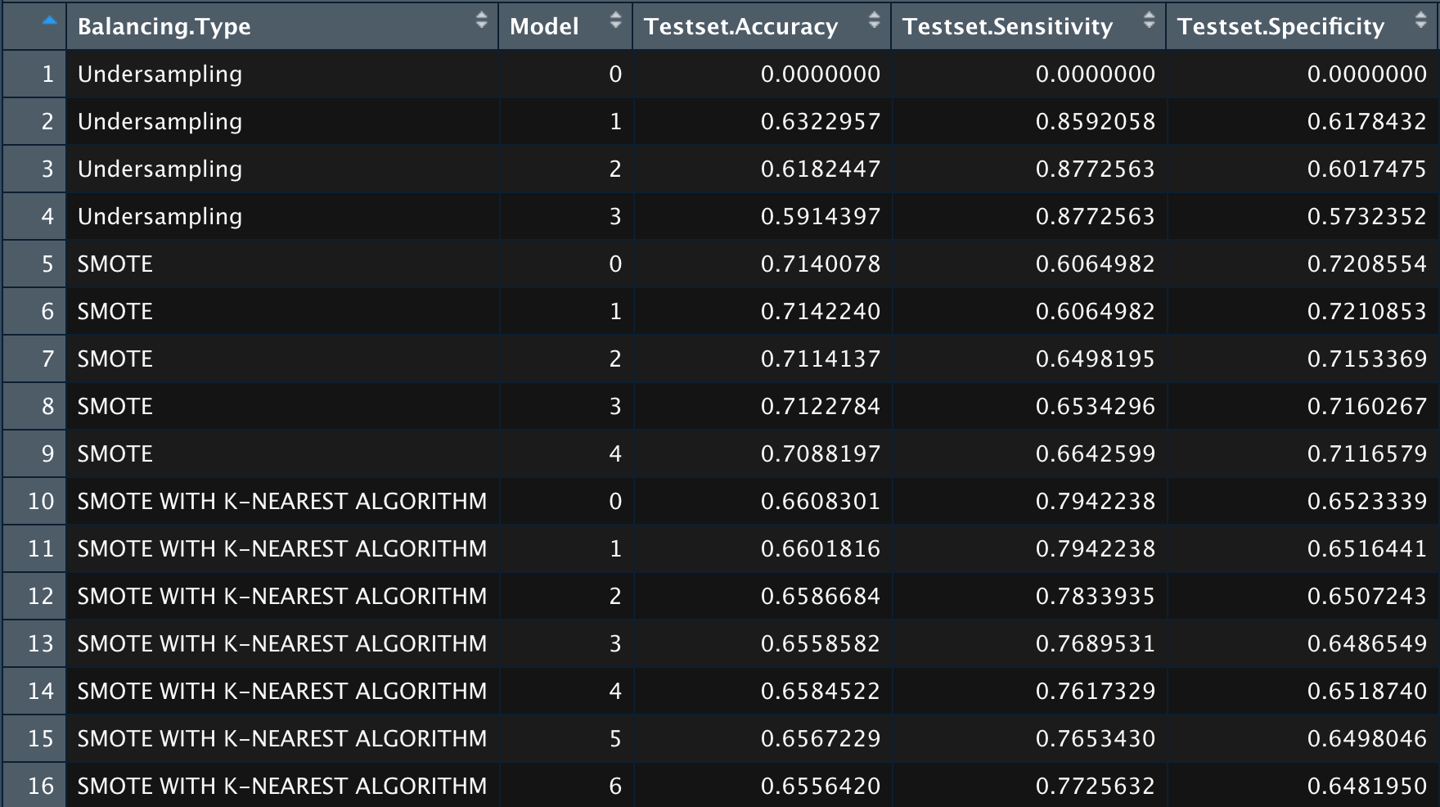

*Figure 10: Test-set Accuracy, Sensitivity and Specificity*

The final logistic regression model has a test-set accuracy of 61.82%, sensitivity of 87.73% and specificity of 60.17%. This means that out of all the cases that were in fact fraudulent, the model has an 87.73% chance of predicting them accurately. This generated a better fraud detection rate than the Association of British Insurers by an increase of 85.68 percentage points. The following confusion matrix shows the prediction of the selected logistic regression model against the actual data.

|  |  |  |  |
| --- | --- | --- | --- |
| Confusion Matrix | | **Predicted** | |
| No Fraud | Fraud |
| **Actual** | No Fraud | 2617 | 34 |
| Fraud | 1732 | 243 |

*Figure 11: Confusion Matrix of Selected Logistic Regression*

As the goal for implementation of machine learning in fraud detection for DAI is cost reduction, in the subsequent subsections, other predictive techniques (Neural Networks and Random Forests) will be used to generate separate machine learning models before evaluating based on sensitivity to determine the optimal technique to use for generating the fraud detection machine learning model for DAI.

### 4.2.4 Model Interpretation

The coefficients of the model refer to the odds ratio of the variable given that all else is constant. For example, given that the fault in the accident is the third party (FaultThirdParty) and all else constant, the probability of fraud will decrease by e2.023387 times or 7.563900528. This means that assuming all else is constant, if the fault is a third party, it is less likely that the claim is not fraudulent.

Refer to Appendix 7.2 for the interpretation of the logistic regression formula. Some qualitative insights were derived from the model.

Firstly, a fraudulent claim due to an accident caused by a third party is unlikely or more difficult to be premeditated. Secondly, sports and newer vehicles possibly increase the likelihood of fraud due to the higher value of the vehicle which could affect the insurance pay-out due to the need for the insurer to pay for the repair of the vehicle. (PolicyBazaar, 2021) Thirdly, if the fault of the accident is on the policyholder, it would more likely be a fraudulent claim as compared to if it was the fault of a third party. Finally, the “All Perils" policy could signify a potential fraud due the wide umbrella of coverage.

The interpretation of the logistic regression model has proven its outperformance over manual fraud investigation methods. It was able to identify counter-intuitive factors like address changes after a claim, and it could even highlight some potential factors that may have been ignored to flag out potential fraud.

## 4.3 Neural Network

### 4.3.1 Brief Introduction to Neural Network

There are 31 independent variables; We are training on two models with different numbers of independent input variables. The first model is called the Full model; all variables in the dataset are included. The second model is called the Hybrid model; variables are selected based on our logistic regression model.

Neural Network mimics a human nervous system, which is made up of interconnected neurons (nodes). In other words, it is made up of interconnected information processing units. The neural network draws from the parallel processing of information of performing more than one job the same time, which is the strength of this method.

The neural network algorithm helps us to extract meaningful information and detect hidden patterns from complex data sets. This method is developed to solve problems that are easy for humans and difficult for machines. For example, identifying pictures like dogs and cats (non-structured data).

We will be using basic Neural Networks that have only a few hidden layers and hidden nodes within each hidden layer.

### 4.3.2 Model development

After normalisation of the Full model there are 105 columns, making training of the neural network model time consuming.

Firstly, the neural network model was trained on 2 different datasets. This is because while training the neural network with the full dataset we realise it is too time consuming. Thus, we want to narrow down the number of variables without decreasing the accuracy of the model. We selected variables for the hybrid model based on the important variables determined by the logistic regression model.

Second, normalisation of the dataset as we believe it will have an impact on predicting fraud. The variables are currently in integer and factor. We need to convert all variables into numerical variables because neural network handles only numerical data. Thus, we use one hot encoding, converting the categorical variables with multiple categories into multiple variables, each with a value of 1 or 0.

However, not all variables are converted to values between 0 and 1 such as age variable. This will affect the development of the model. For example, if age could be up to 100 but the other variables are only up to 1, it might cause the model to apply unnecessary weight or importance to the age variable due to its large number. Thus, the data is normalised with Min-Max Scaling to make all variables between 0 and 1 so that they will be treated with the same importance.

Third, we decided to use undersampling to balance the dataset. This is because when running the dataset rebalanced by SMOTE, it took longer than an hour to train the model. As time efficiency is an important factor that we take into consideration when training the model. The group decided that if the time taken to run the model is too long, it is not a good model. Hence, we decided to set a threshold of 1 hour and exclude any models that take longer than an hour to train.

### 4.3.3 Modelling Process

The number of chosen hidden layers is 1 since we are building a basic neural network model with less complex data.

After choosing the number of hidden layers, we need to choose the number of hidden nodes. The number of hidden neurons should be between the size of the input layer and the output layer. The most appropriate number of hidden neurons is sqrt (input layer nodes * output layer nodes) (Sachdev, 2021). The total number of input variables for the full model is 105, using the formula the number of hidden nodes is 10. While the total number of input variables for the hybrid model is 11, using the formula the number of hidden nodes is 3. However, to ensure the parameters for both neural network models are the same, we standardise the number for both full model and hybrid model to be 10.

Set the number of hidden layers as 1 and hidden nodes as 10 for the full model. The model is evaluated based on a confusion matrix derived from cross-validated test set predictions to determine its accuracy and sensitivity. (Appendix Figure 20)

Set the number of hidden layers as 1 and hidden nodes as 10 for the hybrid model. The model is evaluated based on a confusion matrix derived from cross-validated test set predictions to determine its accuracy and sensitivity. (Appendix Figure 21)

### 4.3.4 Model interpretation

When running the hybrid model, there is a warning error: *Algorithm did not converge in 1 to 1 repetition with the stepmax*. The model will continue to iterate and try finding the best solution (i.e ideal weight contributions from different variables at each neuron and at each layer of the model) until it reaches a point where the overall error of the model is not reduced by more than the default threshold value of 0.01. If the change in error at a given step of iteration is less than 1% the model will stop further optimization. However, when the threshold is 0.01 it hit its stepmax before it could achieve 0.01 so it came up with an error.

Thus, we increase the threshold by 0.01 each time until the threshold does not hit its stepmax before it can achieve the threshold error. Hence, the threshold chosen is 0.03.

### 4.3.5 Model Prediction and Accuracy

|  |  |  |  |
| --- | --- | --- | --- |
| Confusion Matrix | | **Predicted** | |
| No Fraud | Fraud |
| **Actual** | No Fraud | 2580 | 29 |
| Fraud | 1769 | 248 |

*Figure 12: Confusion Matrix of Hybrid Model*



*Figure 13: Final Model’s Accuracy and Sensitivity*

### 4.3.6 Model limitation:

Blackbox

Consensus amongst data science professionals shows that there is little visibility over the neural network’s learning process (Maroto, 2017). While we are aware that the model learns from stochastic gradient descent and backpropagation, there is still uncertainty over how the model learns. The black box impairs the understanding of how the number of hidden layers affects model accuracy and the rationale behind weightings assigned to input factors and nodes.

The lack of explainability would not inspire confidence in our end-users to use our model to predict their fraud.

Fluctuating model accuracy

Despite the set seed, we observed fluctuations in model accuracy. This is because neuralnet randomly assigns starting weights to the variables (Ananthram, 2018), independent of the seed value.

Time consuming training process

Time taken to run the neural network increases with more variables, hidden layers and nodes, which is not desirable as most companies prioritise efficiency in models.

## 4.4 Random Forest Classifier

### 4.4.1 Brief Introduction to Random Forest Classifier

Random Forest is an ensemble learning method. In Random Forest, many decision trees are constructed on various subsets of the dataset. The random forest then takes the prediction from each tree and based on the majority votes of predictions, predicts the final output. Random Forest helps to avoid overfitting of decision trees.

In R’s implementation of Random Forest, we can set the number of decision trees to be constructed and the number of randomly selected variables for each split. Random Forest can perform well without much hyper-parameter tuning. We set 5 random variables per split based on the default optimal settings and tuned the number of trees based on the accuracy of a validation set.

### 4.4.2 Model Development

We utilised the randomForest library in R to create the predictive model.

From the results, we discovered that while SMOTE(M2) and SMOTE with KNN(M3) yielded higher trainset accuracy and sensitivity, the test-set sensitivity for these 2 methods were very low.

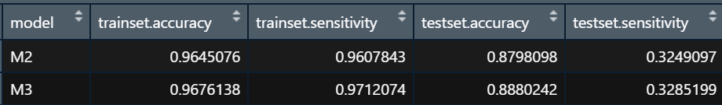

*Figure 14: Drastic Decrease in Test-set Sensitivity Seen*

Since our focus is on accurately predicting and detecting instances of fraud, we decided to go with Undersampling (M1), where the trade-off between accuracy and sensitivity is acceptable.

### 4.4.3 Final Model

Random Forest has 2 ways of measuring variable importance. The first measure is based on how much the accuracy of the model decreases when a variable is excluded. The second measure is based on the decrease of Gini impurity when a variable is chosen to split a node. We have chosen the first measure for the random forest model to determine the important variables. This approach directly measures variable importance by observing how random re-shuffling of each predictor influences model performance.

From the variable importance plot below, we can see that Fault, BasePolicy, VehicleCategory are a few of the important variables in the prediction of FraudFound_P. These variables are similar to those identified by the logistic regression model.

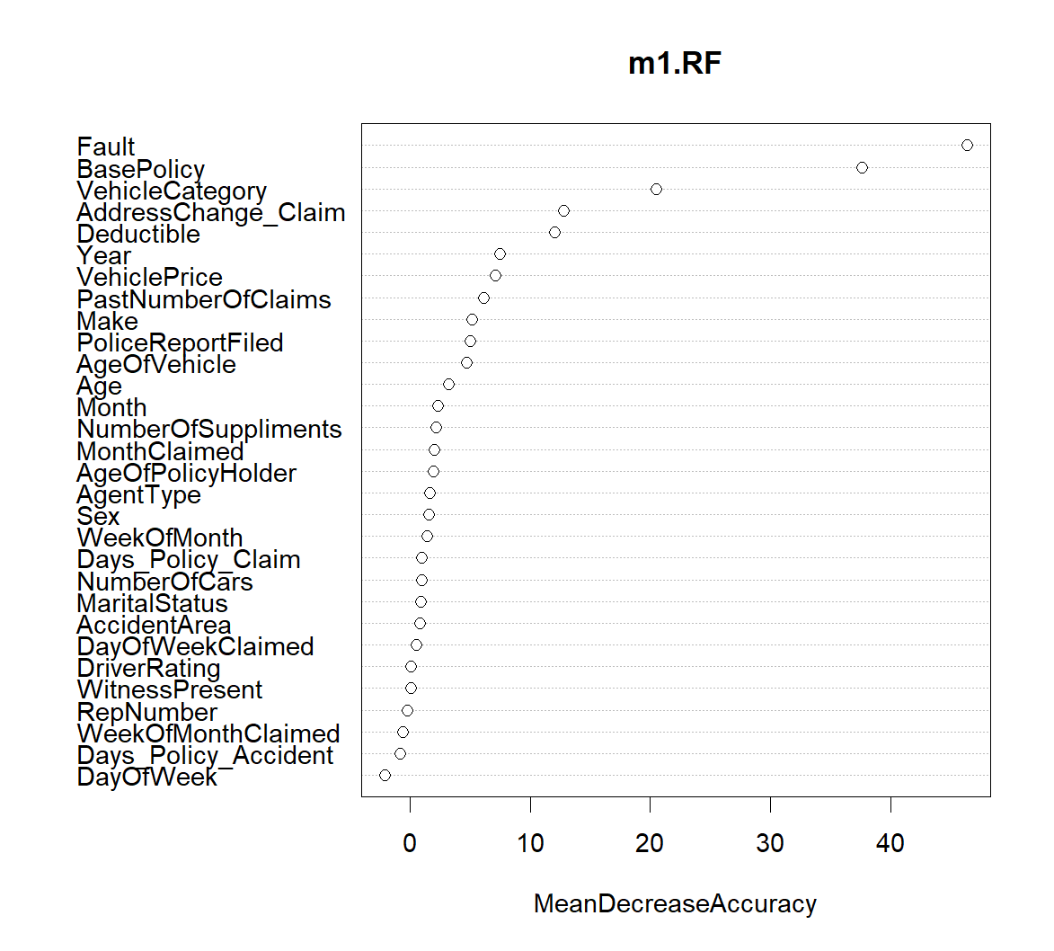

*Figure 15: Variable Importance Plot*

### 4.4.4 Model Prediction and Accuracy

|  |  |  |  |
| --- | --- | --- | --- |
| Confusion Matrix | | **Predicted** | |
| No Fraud | Fraud |
| **Actual** | No Fraud | 2591 | 1758 |
| Fraud | 16 | 261 |

*Figure 16: Confusion Matrix*



*Figure 17: Final Model’s Accuracy, Sensitivity and Specificity*

This model achieved 63.08% accuracy of predicting when an insurance claim is fraudulent, and a 94.22% sensitivity. Since we want to predict the occurrence of fraud when there is actual fraud occurring, a 94.22% sensitivity reflects that this model has performed well without foregoing specificity of 61.21%.

# Application of Findings

## 5.1 Final Model

|  |  |  |  |
| --- | --- | --- | --- |
| **Model** | **Accuracy** | **Sensitivity** | **Specificity** |
| **Logistic Regression** | 61.82% | 87.73% | 60.17% |
| **Neural Network** | 62.56% | 86.64% | 59.32% |
| **Random Forest** | 63.08% | 92.42% | 61.21% |

While all models from the 3 machine learning techniques have been an improvement from the existing detection rates, the Random Forest model is the superior model.

The random forest model yields the **highest sensitivity and specificity** which translates to the **lowest cost** to DAI and would solve their issue of having difficulty detecting insurance fraud occurrences with limited data.

## 5.2 Insights of Model

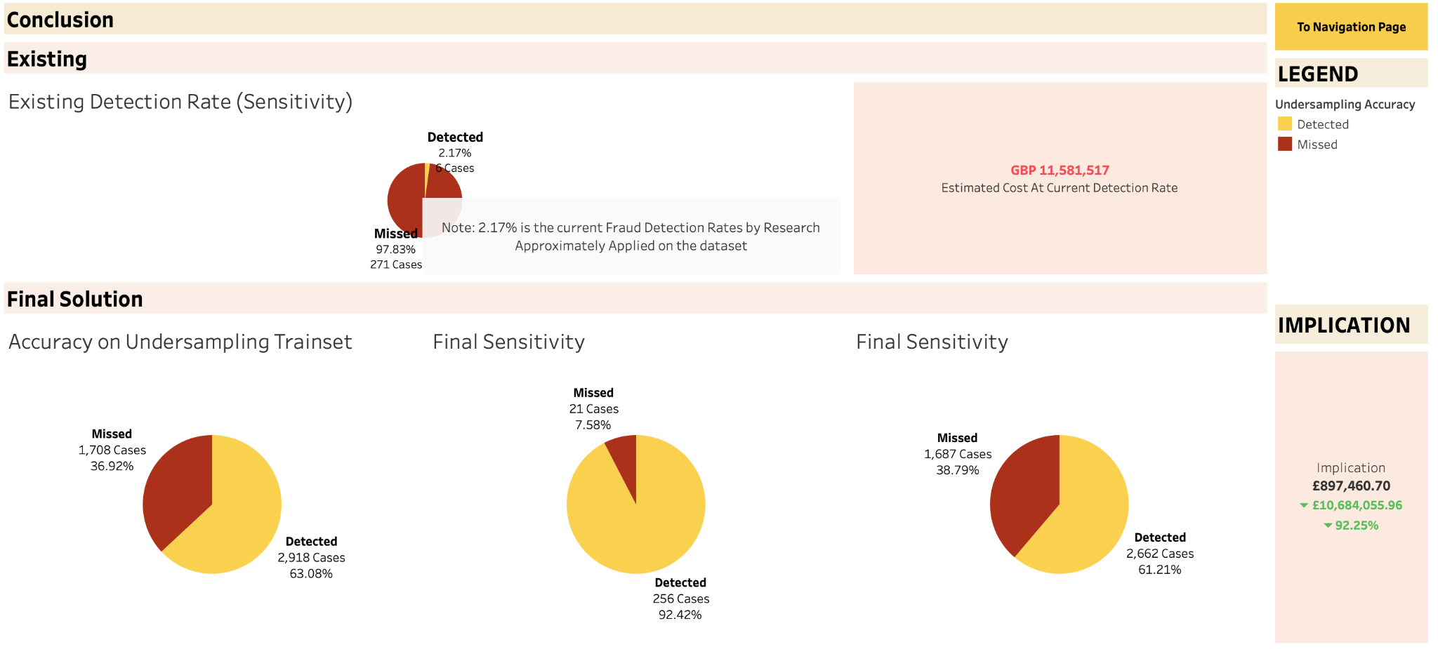

*Figure 18: Dashboard Conclusion*

There are 2 main cost implications on DAI in the case of insurance fraud:

1. The cost of being unable to detect fraud (False-Negatives - Maximising Sensitivity)
2. The cost of fraud investigation when there is in fact no fraud. (False-Positives - Maximising Specificity)

While there is a lack of information on the latter, the cost estimate for **each** undetected fraud is estimated to be 2,559 pounds.

Referring to figure X above, the final solution has significantly higher sensitivity than the existing simulated sensitivity (existing detection rate). This decrease in false negative rates would result in a **92.25%** estimated decrease in cost of about **10.7 million pounds.**

Therefore, with the limited information and data like the standing situation at DAI, the model was able to produce exceptional results and cost savings, should be implemented in DAI.

## 5.3 Business Recommendations

With the insights presented, the team proposes the following recommendations.

### 5.3.1 Web-Based Application with Underlying Random Forest

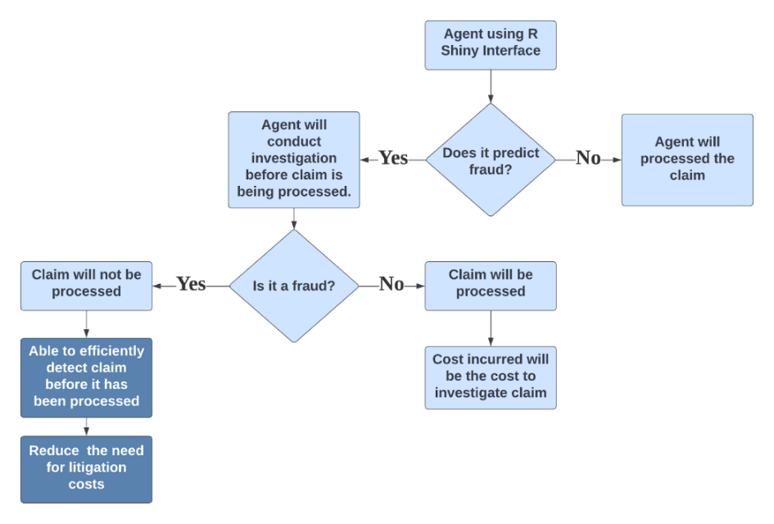

*Figure 19: Roadmap for Graphical Interface Implementation*

*Phase 1: Model Development*

Tackling the main issue of DAI not being able to access customer data from other insurers to predict fraud manually, it has been proven that a successful model can be built based on limited data of 1292 records.

Therefore, DAI can utilise their own historical data to attempt to train a Random Forest model and would not need to rely on GIA to predict the fraud.

*Phase 2: Implementation*

1. User Friendly Graphical Interface
   1. Utilising R’s “shiny” package to create the interface, staff at DAI are able to input the relevant claimants’ information into the interface to obtain the verdict of whether the claimant is fraudulent.
2. Investigation of Detected Fraud
   1. For cases with a **higher risk of fraudulent activity,** the agent will be able to increase investigation efforts using the important variables highlighted by the model. For example, the fault of the accident is the largest determinant of the Random Forest whether it is predicted to be a fraud or not. The agent will then be able to focus on investigating the fault and the cause of the accident.
   2. This establishes a **first line of checking** which would prevent litigation costs incurred should the claim be discovered as a fraud after it has been processed.
3. Strengthening of Model
   1. As new inputs are entered into the interface, the information can be stored into a new dataset along with the correct outcome after the investigation. This would improve the predictive performance of the model over time.

An R Shiny web interface prototype was built as a proof-of-concept to demonstrate how the web-based application with the underlying random forest model should work for DAI to predict fraud.

Referring to the screenshot below, the application has drop down lists and sliders for the user to input the variable values. The user will then select “Predict” after and the output will be shown below in figure X. To demonstrate the underlying random forest model, a fraud case from the data is input into the system to achieve a fraud prediction. Refer to the appendix to view the entire data input and the data it was derived from. Given that this is a proof-of-concept, the application can be further improved by styling using Cascading Style Sheets.

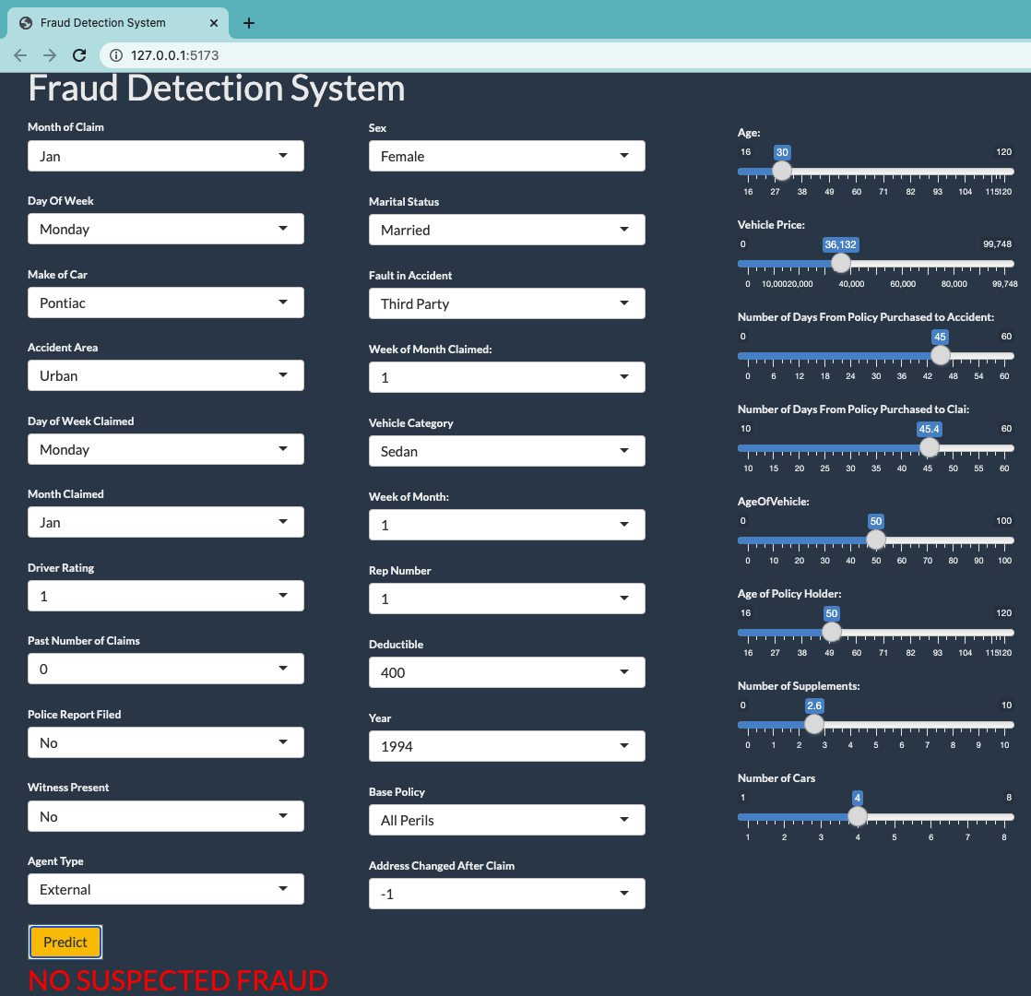

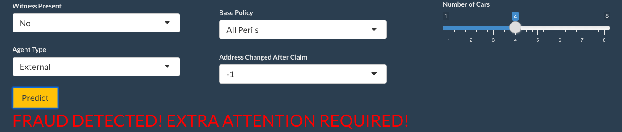

*Figures 20: Screenshot of Shiny Web-Based Application*

### 5.3.2 Fraud Deterrence and Mitigation using Real Time Insights

As Tableau is connected to datasets, DAI would be able to monitor the dashboards in real time. DAI can use code snippets to auto-refresh the datasets connected to the machine learning models script. (Samuel, 2021) This would allow the dashboards to be updated almost in real-time.

With the interactive and real-time data, DAI can now

1. Monitor their overall fraud detection rate and cost implications
2. Understand what are some factors that seem to be present in a policyholder that will result in a fraudulent claim
3. Deter potential fraudsters or serial fraudsters from becoming a policyholder by performing a thorough investigation before the purchase of insurance policies.

Understanding the factors in a fraudulent claim would prevent DAI from being vulnerable to serial fraudsters or potential frauds. For example, using the logistic regression model’s insights, it can be inferred that some variables such as sports vehicles, newer vehicles and all perils coverage policies seem to increase the likelihood of fraud. DAI would then be able to deter the occurrence of fraud in several ways listed below.

Firstly, DAI can potentially be more selective about their policyholders. By identifying applicants that fall under categories prone to fraudulent activities, such as applicants with a high number of past insurance claims. A consideration for this recommendation would be how it affects DAI’s reputation to gauge if it is worth implementing.

Secondly, DAI should alter the premiums, pay-outs, or coverage of the policies for policyholders of these categories, which are more prone to fraud, to make it less feasible and less economically beneficial for fraudsters to attempt fraud in DAI.

Finally, DAI can also include clauses within these policies that would make it harder for premeditated fraudulent claims such as planned accidents. For example, as it has been identified that sports vehicles have a higher chance of fraudulent claims, DAI may update sports vehicles insurance to only include coverage for fault of third party with higher premiums and lower deductibles.

DAI can also use it to further aid the fraud investigation team during their investigation as a point of focus. Using the important variables diagram in the dashboard, users can understand the factors that result in the model prediction. For example, random Forest highlighted important variables such as those similar to logistic regression which could aid their investigation to ascertain fraud. For example, the Agent type could signify a collaborated fraud between agents and policyholders depending on the agent, or past claims could be looked into to investigate those with a high number of claims.

## 5.4 Limitations

However, there were some limitations for the team in performing this development and evaluation. Firstly, there were no documentation or data dictionary from the source of the data which makes it difficult to determine the true interpretation some of the variables in the dataset. All the variable meanings in this dataset were determined based on our own assumptions and interpretations of the variables.

Secondly, due to the lack of information in the insurance industry especially in the local context, this report assumes that all insurance companies globally have the same capability and detection rate. It was also assumed that costs in the UK would be the same as in Singapore.

Finally, the lack of local data sources also made it difficult to demonstrate the feasibility in the local context.

Therefore, these limitations and assumptions should be taken into consideration when DAI applies this proof-of-concept in the local context.

## 5.5 Conclusion

Machine learning techniques have proven their efficacy and versatility. It will be able to allow DAI to achieve higher detection rates, independence, lower costs, and increased time efficiency in their fraud detection process. Its versatility has also shown that it can be applied via a web-based application and dashboard for non-technical users to gain insights from and to improve the process. Therefore, DAI would significantly benefit from the implementation of machine learning techniques and user-targeted

# References

Ananthram, A. (2018b, July 9). *Random Initialization For Neural Networks : A Thing Of The Past*. Medium. Retrieved 3 April 2022, from https://towardsdatascience.com/random-initialization-for-neural-networks-a-thing-of-the-past-bfcdd806bf9e

Ang, S. (2022, January 10). *Reports of insurance fraud tripled between 2018 and 2020: Shanmugam*. The Straits Times. Retrieved 2 April 2022, from https://www.straitstimes.com/singapore/politics/reports-of-insurance-fraud-tripled-between-2018-and-2020-shanmugam

DirectAsia Insurance. (2019, January 29). *How Gender Affects Car Insurance Rates*. Retrieved 2 April 2022, from https://www.directasia.com/blog/how-gender-affects-car-insurance-rates/

Harrison, O. (2019, July 14). *Machine Learning Basics with the K-Nearest Neighbors Algorithm*. Medium. Retrieved 2 April 2022, from https://towardsdatascience.com/machine-learning-basics-with-the-k-nearest-neighbors-algorithm-6a6e71d01761

Hoare, J. (2021, June 9). *How is Variable Importance Calculated for a Random Forest?* Displayr. Retrieved 3 April 2022, from https://www.displayr.com/how-is-variable-importance-calculated-for-a-random-forest/

Hodges, M. (2022, February 8). *Is Car Insurance Cheaper When Married?* Metromile. Retrieved 2 April 2022, from https://www.metromile.com/blog/marriage-affect-auto-insurance-cost/

Lewinson, E. (2021, December 7). *Explaining Feature Importance by example of a Random Forest*. Medium. Retrieved 3 April 2022, from https://towardsdatascience.com/explaining-feature-importance-by-example-of-a-random-forest-d9166011959e

*Machine Learning Random Forest Algorithm - Javatpoint*. (n.d.). Www.Javatpoint.Com. Retrieved 2 April 2022, from https://www.javatpoint.com/machine-learning-random-forest-algorithm

Malhotra, R., & Sharma, S. (2018). *Machine Learning in Insurance*. Accenture. https://www.accenture.com/_acnmedia/pdf-84/accenture-machine-leaning-insurance.pdf

Maroto, M. (2018, April 3). *Neural Networks = Black Box? - Towards Data Science*. Medium. Retrieved 3 April 2022, from https://towardsdatascience.com/neural-networks-black-box-b20723f9a417

McKinnon, D., Chan, H. S., & Chan, K. K. (2020, September). *The fight against insurance fraud Singapore*. Crawford. https://assets.crawco.com/docs/global-resource-insurance-fraud.pdf

PolicyBazaar. (2021, August 26). *Does the value of car affect insurance?* Retrieved 2 April 2022, from https://www.policybazaar.com/motor-insurance/car-insurance/articles/does-the-value-of-car-affect-insurance-premiums/

Sachdev, H. S. (2021, April 20). *Choosing number of Hidden Layers and number of hidden neurons in Neural Networks*. LinkedIn. Retrieved 2 April 2022, from https://www.linkedin.com/pulse/choosing-number-hidden-layers-neurons-neural-networks-sachdev/?trackingId=Wk4HLmqFRfa8kmI%2FMvBuHw%3D%3D

Samuel, N. (2022, April 1). *Tableau Real Time Data Streaming: 2 Easy Methods*. Learn | Hevo. Retrieved 2 April 2022, from https://hevodata.com/learn/tableau-real-time-data-streaming/#desktopAutoRefresh

Tan, C. (2022, March 24). *Rise in serious accidents in Singapore takes toll on insurers’ bottom line*. The Straits Times. Retrieved 2 April 2022, from https://www.straitstimes.com/singapore/transport/rise-in-serious-accidents-in-singapore-takes-toll-on-insurers-bottom-line

Tarling, M., Dawson, L., & Aspinall, S. (2021, October 6). *No Time to Lie - the average fraudulent insurance claim rises to £12,000 as insurers continue protecting honest customers ABI*. Association of British Insurance. Retrieved 2 April 2022, from https://www.abi.org.uk/news/news-articles/2021/10/detected-fraud-2020/#:%7E:text=The%20ABI’s%20latest%20detected%20general,a%20lower%20rate%20of%204%25

# Appendix

## 7.1 Data Dictionary

|  |  |
| --- | --- |
| Month | months in which the accident occured |
| WeekOfMonth | week in the month the accident occured |
| DayOfWeek | days of the week the accident occured |
| Make | Make of the vehicle involved (list of 19 car manufacturers) |
| AccidentArea | Accident area (classify as either ‘urban’ or ‘rural’) |
| DayOfWeekClaimed | day of the week the claim was filed |
| MonthClaimed | Month in which the claim was filed |
| WeekOfMonthClaimed | weeks in the month that the claimed in filed |
| Sex | gender of individual making claim |
| MaritalStatus | marital status of individual making claim |
| Age | ages of individual making claim |
| Fault | categorization of who was deemed at fault (‘0’ = not at fault, ‘1’= at fault) |
| PolicyType | contains two pieces of info:   * category of the vehicle (sport, sedan, utility) * the type of insurance on the car (liability, all perils, collision) |
| VehicleCategory | category of the vehicle (sport, sedan, utility) |
| VehiclePrice | ranges for the value of the vehicle |
| FraudFound_P | indicate whether claim was fraudulent (‘0’ = not fraud, ‘1’= fraud) |
| PolicyNumber | the masked policy number |
| RepNumber | ID of the representative handling claim |
| Deductible | the deductible amount |
| DriverRating | Driver ratings (Higher number equivalent to better ratings, range: 1-4) |
| Days_Policy_Accident | the number of days between when the policy was purchased and the accident occured |
| Days_Policy_Claim | the number of days that pass between the policy was purchased and the claim was filed |
| PastNumberOfClaims | previous number of claims filed by policy holder |
| AgeOfVehicle | age of vehicle at time of the accident |
| AgeOfPolicyHolder | Range of age of policy holder |
| PoliceReportFiled | Whether a police report was filed (no, yes) |
| WitnessPresent | whether a witness was present (no, yes) |
| AgentType | classifies an agent who is handling the claim as internal vs external |
| NumberOfSuppliments | Number of insurance policies that supplements the primary insurance coverage (range of values: none, 1 to 2, 3 to 5, more than 5) |
| AddressChange_Claim | time from claim was filled to when person moved in years (integer and range) |
| NumberOfCars | number of cars covered under policy |
| Year | year accident occured |
| BasePolicy | type of insurance coverage (All Perils, Collision, Liability) |

## 7.2 Logistic Regression Model Interpretation

The formula of the selected logistic regression is as follows:

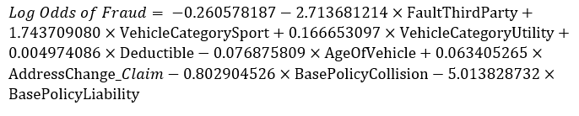

* The output of the formula is log odds of frauds which means the probability of fraud would be 1/(1+elog odds of fraud).
* Given all else constant, odds of fraud will decrease by a factor of 0.75 (e-2.713681214) if the fault belongs to a third party instead of the policy holder.
* Given all else constant, odds of fraud will increase by a factor of 5.72 (e1.743709080) or 1.18 (e0.166653097) if the vehicle category was Sport or Utility rather than sedan respectively.
* Given all else constant, odds of fraud will increase by a factor of 1.005 (e0.004974086) for every $1 increase in deductible. Policies with higher deductibles usually have lower premiums, this could signify a premeditated fraud of having low premium insurance policies to commit fraud.
* Given all else constant, odds of fraud will decrease by a factor of 0.9260048 (e-0.076875809) for every 1 additional year of vehicle’s age. Similar to the vehicle category, the value of the car could affect the insurance pay-out thus the likelihood of it being a fraud increases.
* Given all else constant, odds of fraud will increase by a factor of 1.065 (e0.063405265) for every additional year of address changed after claim.
* Given all else constant, odds of fraud will decrease by a factor of ​​0.448 (e-0.802904526) or 0.00665 (e-5.013828732) if the base policy was collision or liability rather than “All Perils” respectively.
* The intercept (without variable) in the formula is the log odds when all else is 0 or absent.

## 7.3 Model Prediction and Accuracy of Neural Network

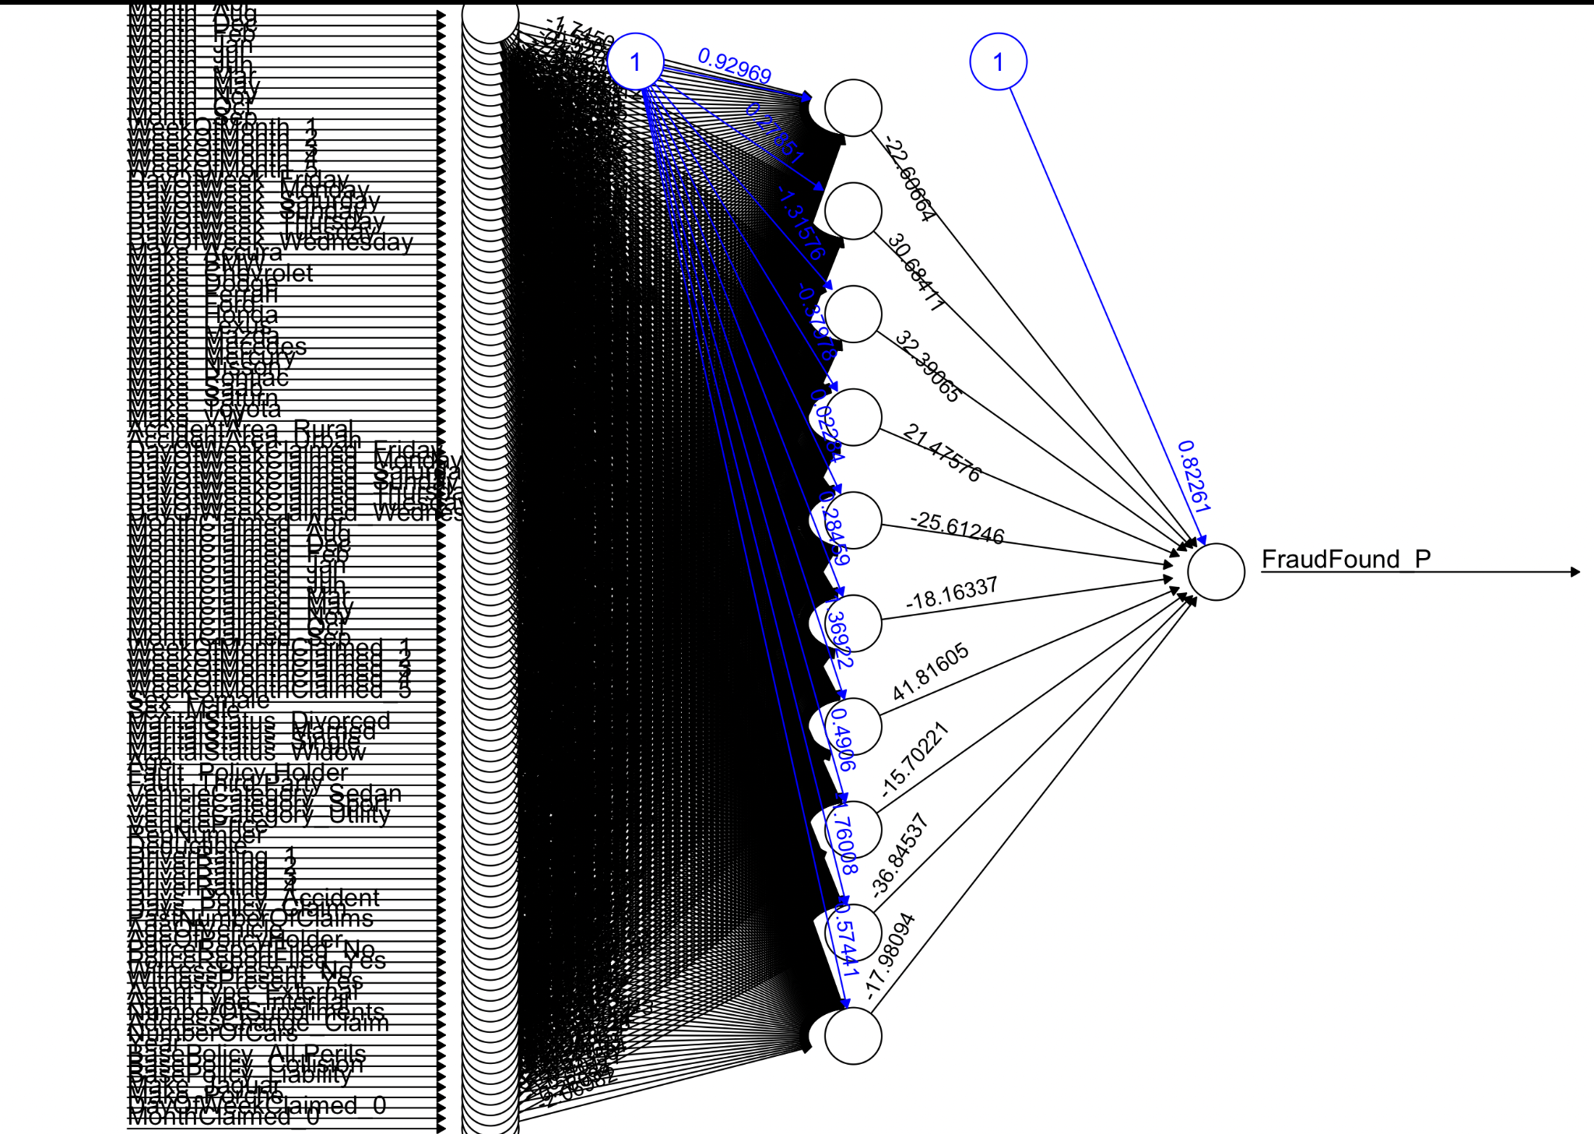

*Figure 21: Neural Net Tree of Full Model*

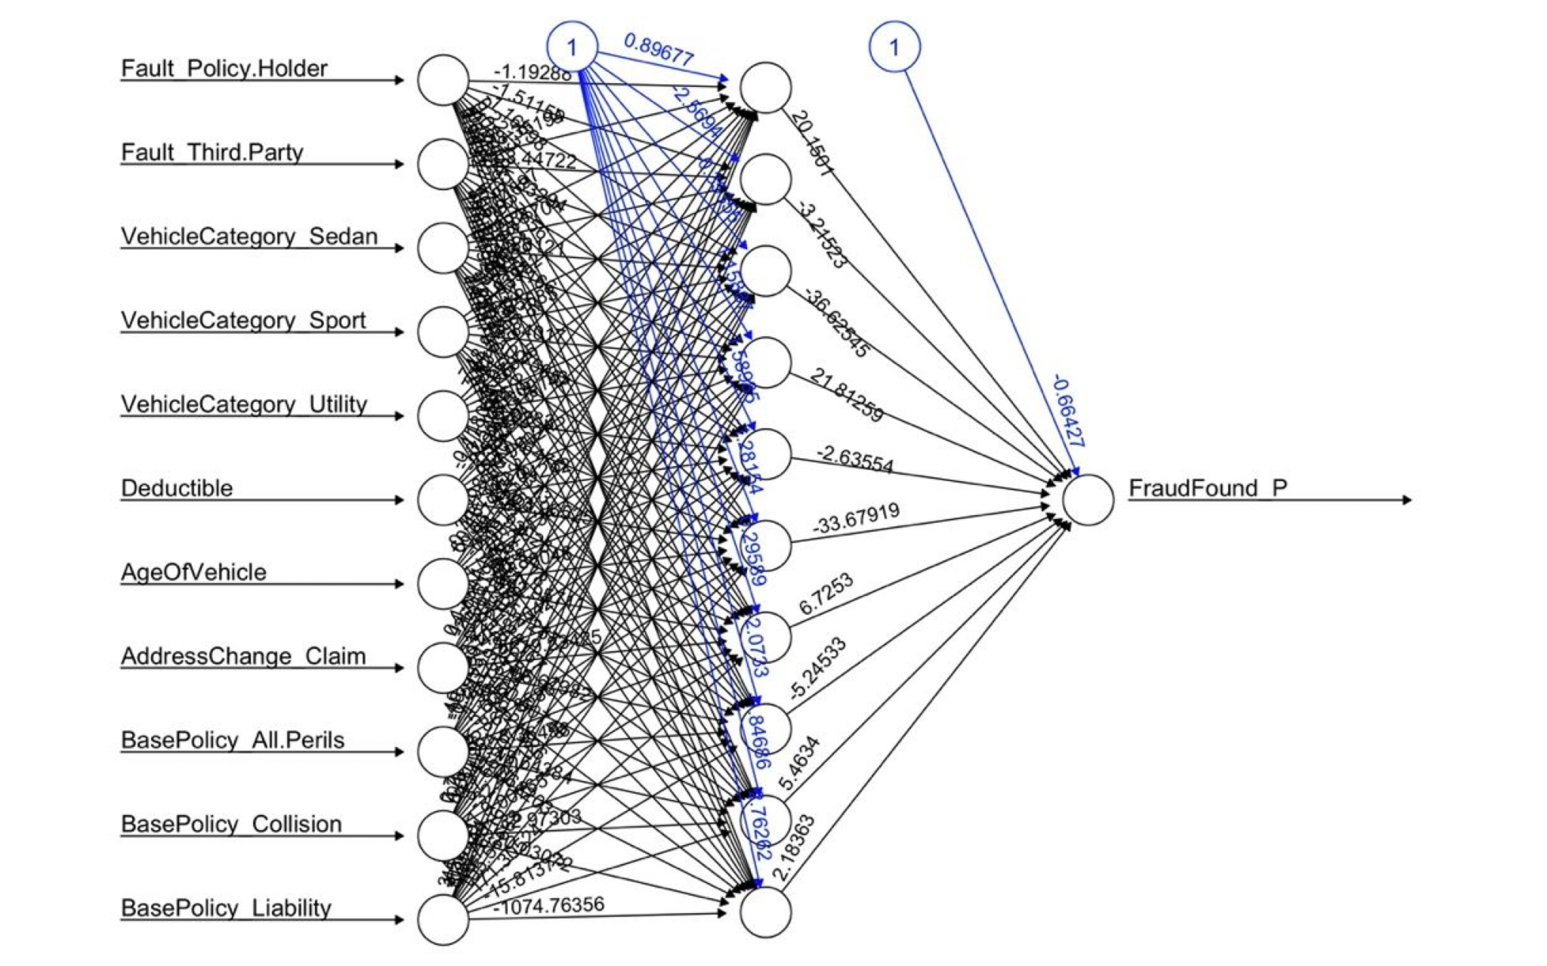

*Figure 22: Neural Net Tree of Hybrid Model*

Neural net model:

Train-set:

|  |  |  |  |
| --- | --- | --- | --- |
| Confusion Matrix | | **Predicted** | |
| No Fraud | Fraud |
| **Actual** | No Fraud | 646 | 0 |
| Fraud | 0 | 646 |

*Figure 23: Confusion Matrix of Neural Net Model Trainset*

Test-set:

|  |  |  |  |
| --- | --- | --- | --- |
| Confusion Matrix | | **Predicted** | |
| No Fraud | Fraud |
| **Actual** | No Fraud | 2934 | 101 |
| Fraud | 1415 | 176 |

Figure 24: Confusion Matrix of Neural Net Model Test-set

Hybrid Model:

Trainset:

|  |  |  |  |
| --- | --- | --- | --- |
| Confusion Matrix | | **Predicted** | |
| No Fraud | Fraud |
| **Actual** | No Fraud | 393 | 31 |
| Fraud | 253 | 615 |

*Figure 25: Confusion Matrix of Hybrid Model Trainset*



*Figure 25: Random Forest Models on 3 Differently Balanced Trainset Data*

## 7.4 Dashboard

### 7.4.1 Logistic Regression Dashboard

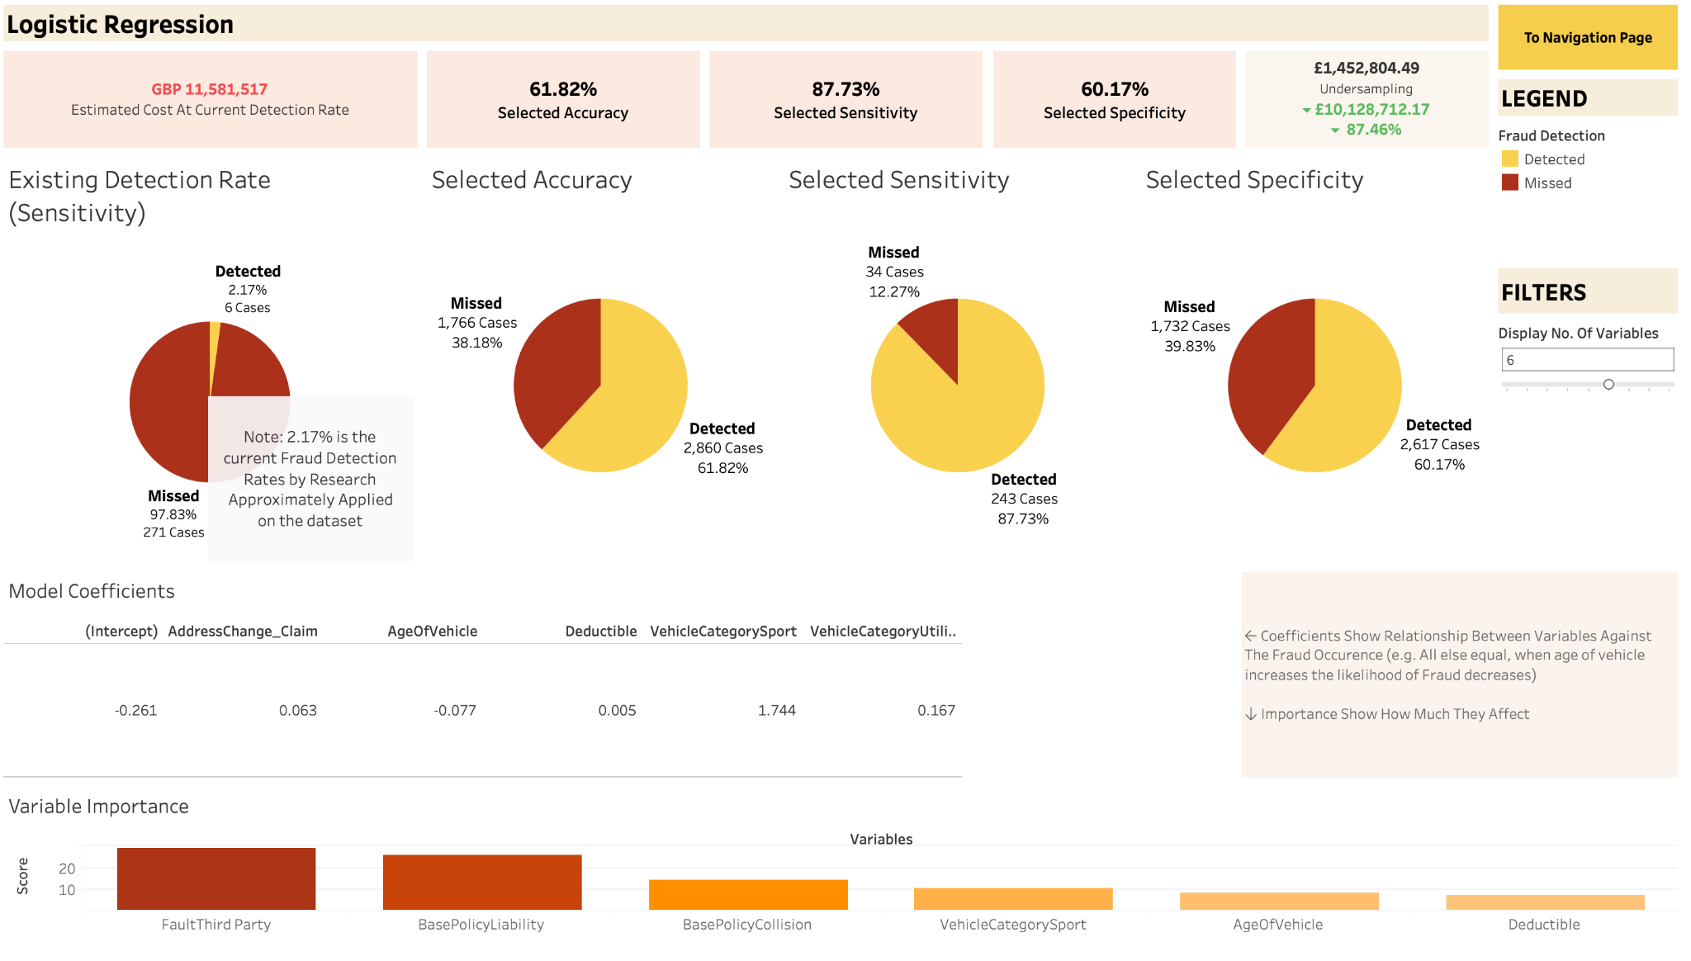

### 7.4.2 Neural Network Dashboard

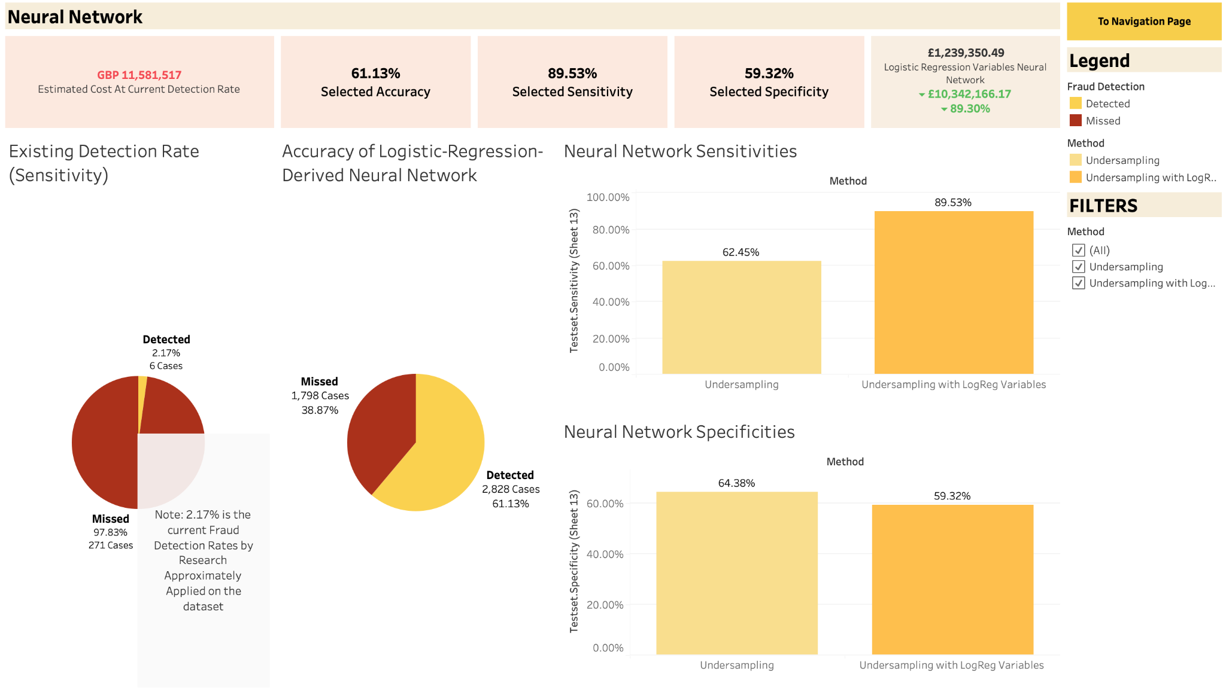

### 7.4.1 Random Forest Dashboard

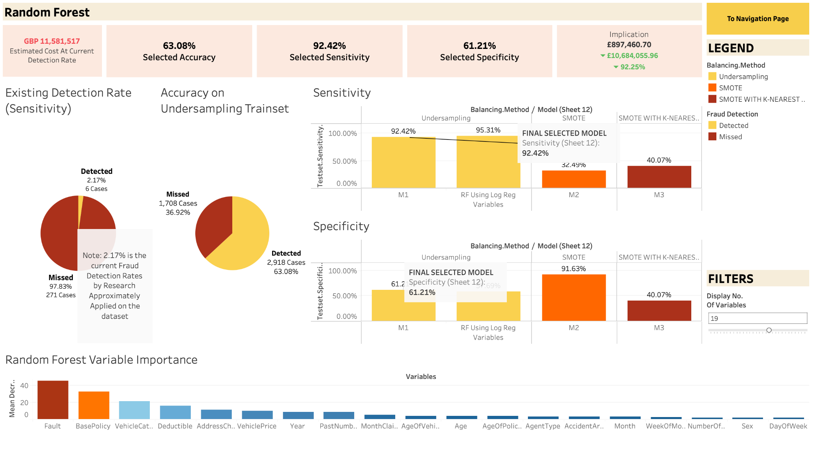

## 7.5 R Shiny Web-Based Application Proof-Of-Concept

### 7.5.1 Actual Data







 (1 = Fraud Found)

### 7.5.2 Application Demonstration

